Ex. No. : 01A Date: 21.01.2026
Register No.: 231701046 Name: Sam Sundar

GUI Components
Aim:
Develop an application to change the font and color of the text and display toast message when the user presses the button.
Procedure:
- Create a New Android Project
  - Open Android Studio.
  - Click on New Project → Select Empty Activity.
  - Enter the Application Name, Package Name, and select Kotlin as the language.
  - Click Finish.
- Configure AndroidManifest.xml
  - Open AndroidManifest.xml.
  - Ensure that the MainActivity is declared.
  - Set the launcher intent so that the app starts with MainActivity.
- Design the User Interface
  - Open activity_main.xml.
  - Use a LinearLayout with vertical orientation.
  - Add a TextView to display text.
  - Add three Buttons:
    - Change Font Size
    - Change Font Color
    - Change Background Color
  - Assign proper IDs to all views.
- Write Kotlin Code
  - Open MainActivity.kt.
  - Use setContentView() to load the layout.
  - Access UI elements using findViewById().
  - Implement setOnClickListener() for each button:
    - Font Size Button: Increases text size cyclically.
    - Font Color Button: Changes text color among predefined colors.
    - Background Color Button: Changes background color of the layout.
- Run the Application
  - Connect an Android Emulator or physical device.
  - Click Run ▶ in Android Studio.
  - Observe the changes when buttons are clicked.
- Verify Output
  - Text size changes on clicking Change Font Size.
  - Text color changes on clicking Change Font Color.
  - Background color changes on clicking Change BG Color.

AndroidManifest.xml

<?xml version="1.0" encoding="utf-8"?>
<manifest xmlns:android="http://schemas.android.com/apk/res/android"
xmlns:tools="http://schemas.android.com/tools">
<application
android:allowBackup="true"
android:dataExtractionRules="@xml/data_extraction_rules"
android:fullBackupContent="@xml/backup_rules"
android:icon="@mipmap/ic_launcher"
android:label="@string/app_name"
android:roundIcon="@mipmap/ic_launcher_round"
android:supportsRtl="true"
android:theme="@style/Theme.Experiment1_MADD_46">
<activity
android:name=".MainActivity"
android:exported="true">
<intent-filter>
<action android:name="android.intent.action.MAIN" />
<category android:name="android.intent.category.LAUNCHER" />
</intent-filter>
</activity>
</application>
</manifest>

Activity_main.xml

<?xml version="1.0" encoding="utf-8"?>
<LinearLayout xmlns:android="http://schemas.android.com/apk/res/android"
xmlns:app="http://schemas.android.com/apk/res-auto"
xmlns:tools="http://schemas.android.com/tools"
android:id="@+id/main"
android:layout_width="match_parent"
android:layout_height="match_parent"
tools:context=".MainActivity"
android:orientation="vertical"
>
<TextView
android:id="@+id/tv"
android:gravity="center"
android:layout_width="match_parent"
android:layout_height="232dp"
android:text="Hi Thala"
app:layout_constraintBottom_toBottomOf="parent"
app:layout_constraintEnd_toEndOf="parent"
app:layout_constraintStart_toStartOf="parent"
app:layout_constraintTop_toTopOf="parent"
app:layout_constraintVertical_bias="0.273" />
<Button
android:id="@+id/btntxtsize"
android:layout_width="match_parent"
android:layout_height="wrap_content"
android:text="Change Font Size"
tools:layout_editor_absoluteX="149dp"
tools:layout_editor_absoluteY="257dp" />
<Button
android:id="@+id/btntxtcolor"
android:layout_width="match_parent"
android:layout_height="wrap_content"
android:text="Change Font Color"
tools:layout_editor_absoluteX="129dp"
tools:layout_editor_absoluteY="321dp" />
<Button
android:id="@+id/bgcolor"
android:layout_width="match_parent"
android:layout_height="wrap_content"
android:text="Change BG Color"
tools:layout_editor_absoluteX="149dp"
tools:layout_editor_absoluteY="394dp" />
</LinearLayout>

MainActivity.kt

package com.example.experiment_1_madd_46
import android.os.Bundle
import android.widget.TextView
import android.widget.Button
import android.graphics.Color
import android.widget.LinearLayout
import androidx.activity.enableEdgeToEdge
import androidx.appcompat.app.AppCompatActivity
import androidx.core.view.ViewCompat
import androidx.core.view.WindowInsetsCompat
class MainActivity : AppCompatActivity() {
override fun onCreate(savedInstanceState: Bundle?) {
super.onCreate(savedInstanceState)
enableEdgeToEdge()
setContentView(R.layout.activity_main)
val main = findViewById<LinearLayout>(R.id.main)
val tv = findViewById<TextView>(R.id.tv)
val btntxtsize = findViewById<Button>(R.id.btntxtsize)
val btntxtcolor = findViewById<Button>(R.id.btntxtcolor)
val bgcolor = findViewById<Button>(R.id.bgcolor)
var fontSize: Float = 10f
btntxtsize.setOnClickListener {
tv.setTextSize(fontSize)
fontSize = ((fontSize+10)%50)
}
var fontColor: Int=5
btntxtcolor.setOnClickListener {
when(fontColor%5){
0 -> tv.setTextColor(Color.RED)
1 -> tv.setTextColor(Color.YELLOW)
2 -> tv.setTextColor(Color.BLUE)
3 -> tv.setTextColor(Color.GREEN)
4 -> tv.setTextColor(Color.MAGENTA)
}
fontColor++
}
var bg: Int=5
bgcolor.setOnClickListener {
when(bg%5){
1 -> main.setBackgroundColor(Color.RED)
2 -> main.setBackgroundColor(Color.YELLOW)
3 -> main.setBackgroundColor(Color.BLUE)
4 -> main.setBackgroundColor(Color.GREEN)
0 -> main.setBackgroundColor(Color.MAGENTA)
}
bg++
}
}
}

Output:

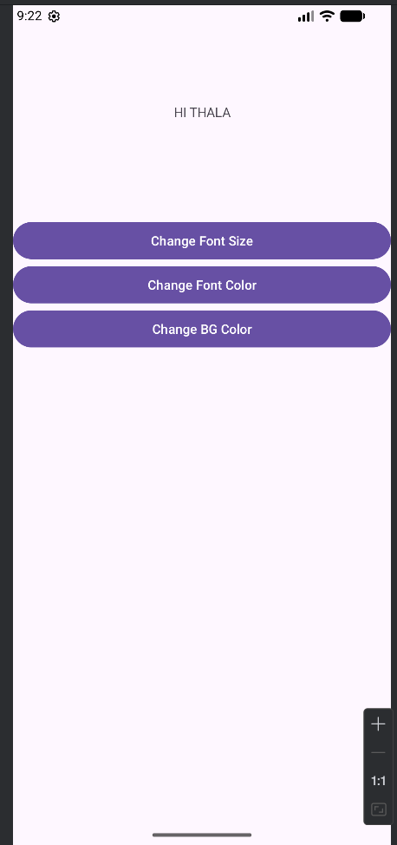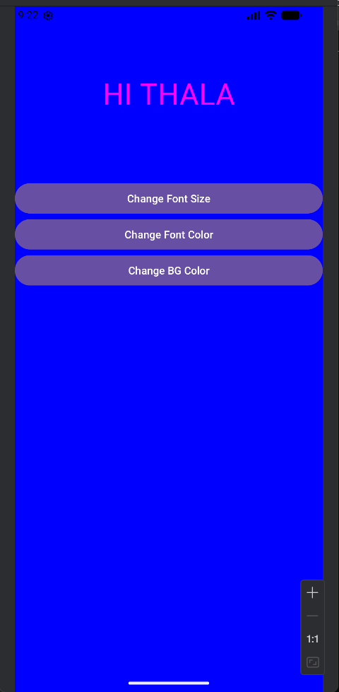

Result:
The Android application was successfully developed to dynamically change text size, text color, and background color using button click events.

